SCIENCE REPORT Balloon Fun! (Yeast and Temperature)
Adrian Woodhouse and Susie Gerraty, Group Q.
VELS Level 4

Introduction

Bread has been called the ‘Staff of Life’ for good reason. In this experiment students learn the difference between leavened and unleavened bread and witness a chemical reaction. They hone and extend skills developed in other parts of the curriculum: close observation, measurement, report writing and research.

The connection to food is a bonus in this investigation. Children (and adults) are sadly ignorant of the mechanics of food production in this day and age. Our health and our household budgets suffer as a result.

- It is possible to build on this experiment with other fun balloon activities involving sourdough, baking soda and vinegar. Or, if circumstances allow, why not bake some bread?

Before Students Begin: Show images of different transformations (i.e. Appendix II, p.6 of Chapter 4 ‘Learning Science through Food Activities’ in Wan Ng, Primary Science Resources) and ask them to ponder whether the changes are physical or chemical.

Guiding Questions: ‘Can you see any bubbles?’ ‘Can you still see the yeast?’ ‘Can you smell anything?’

Purpose
To develop awareness of the effect of temperature on chemical reactions, encourage students to link cause and effect and to expand their awareness of the processes and variables underlying production of the food they consume.

Hypothesis
The leavening properties of Yeast operate most effectively at mid range temperatures.

Materials
5 rubber balloons of identical colour and dimensions.
5 glass bottles 1 timer 1 thermometer
1metre of string 1 30cm ruler 1 cup
5 packets of baker’s yeast. 250g sugar 1 spoon
Water of varying temperatures (chilled to hot)

Method
Balloons were stretched by blowing up and deflating them several times. Hot water was poured into a cup, and temperature was recorded. One packet of yeast and two tablespoons of sugar were added to the water, stirred until dissolved, and poured into the glass bottle. The mouth of a balloon was then stretched over the rim of the bottle, and the timer was started. The balloon size was recorded at 10 minute intervals, using the string and ruler to measure its broadest horizontal point, until 1 hour had elapsed. The process was repeated for decreasing temperatures of water (hot, warm, luke warm, cold, and chilled).

Results
Table 1: Balloon expansion over time at varying temperatures.
 | 0 min | 10 min | 20 min | 30 min | 40 min | 50 min | 60 min
55⁰C | 0 | 0 | 19.5 | 21.5 | 24 | 25 | 27.5
42 ⁰C | 0 | 28.5 | 33 | 35 | 37 | 38 | 39
30 ⁰C | 0 | 19 | 26.5 | 32.5 | 35 | 37 | 39
24 ⁰C | 0 | 0 | 20 | 21.5 | 27 | 34.5 | 36
6 ⁰C | 0 | 0 | 0 | 0 | 0 | 0 | 0
Graph 1: Balloon expansion over time at varying temperatures.

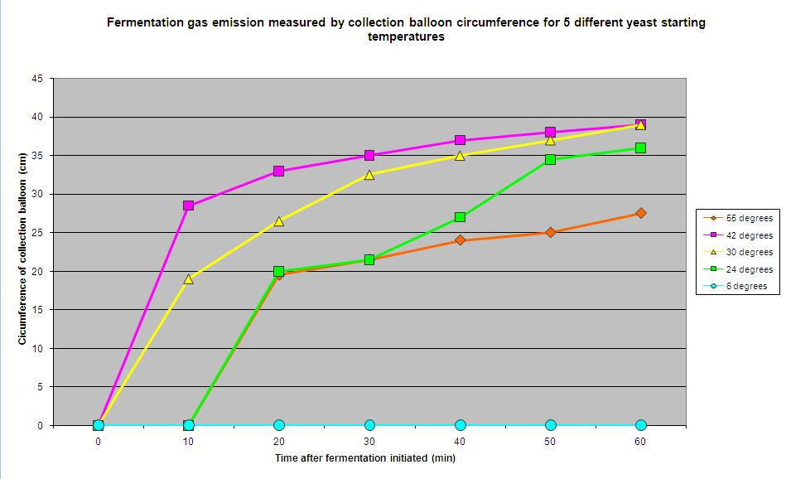
Discussion
The results suggest that temperature has a significant effect on balloon expansion, and therefore yeast activity. Optimum water temperature was 42˚C, followed by 30˚C. Temperatures above and below these samples substantially limited yeast efficiency. This has obvious implications for food preparation and suggests an explanation for the action of letting dough sit in a warm environment for a period of time before baking.
yeast
glucose alcohol + carbon dioxide

(yeast acts as the catalyst for the reaction)

It was interesting to note that at the 3 hour mark of the experiment (not reported in the results), all balloons, except that of the 6˚C starting temperature, had reached the same diameter, suggesting a subsequently confirmed fact that all solutions reached the same (ambient) temperature. It is conceivable that the only result that was truly accurate was that of the 24˚C temperature, as this was also the temperature of the room. Future experiments should counter this limitation by maintaining specific temperatures for each sample throughout the experiment.

Conclusion
The hypothesis that yeast operates most effectively at mid range temperatures was supported by the results. Future experiments should aim to preserve the starting temperatures of samples throughout the experiment.

How we delegated tasks

Research for this experiment was evenly divided. Both partners agreed on the topic for investigation. Susanne purchased all materials and Adrian was Laboratory Boss. This report is the result of a collaborative writing process.

References:

- Ng,Wan, Primary Science Resources
- Sharwood,Jenny, Khun,Monika,(2005), Science Edge 2, Southbank, Thomson Nelson, Southbank

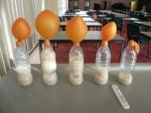

Variation in Balloon Inflation

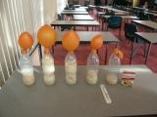

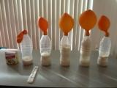

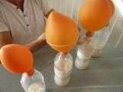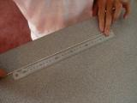

Measuring the diameter of the balloons with string and a ruler

